**MIDDLE EAST TECHNICAL UNIVERSITY**

**ELECTRICAL AND ELECTRONICS ENGINEERING DEPARTMENT**



**EE463 STATIC POWER CONVERSION-I**

**PROJECT #2 REPORT**

**SIMULATION and DESIGN of the HARDWARE PROJECT**

**DESIGN of an INSULATED POWER SUPPLY**

**Due Date: 31.03.2019**

**Team Members:**

**Furkan TOKGÖZ 2031458**

**İven GÜZEL 2030831**

**Anılcan BUDAK 2093490**

Table of Contents

Table of Contents 2

1. INTRODUCTION 3

2. DESIGN of an INSULATED POWER SUPPLY 3

Part a: Steady State Operation of the Forward Converter 3

Part b: Design of the Transformer 5

Part c: Simulation of the converter with ideal switches and transformer 7

Part d: Border of DCM 8

Part e: More Realistic Transformer Simulation 9

Part f: Efficiency of the Converter 10

Part g: Converter Operation 11

Part h: Preliminary Component Selection 12

3. COCNLUSION 13

# INTRODUCTION

In this project, designing an insulated power supply for the hardware project of EE464-Spring 2019 is aimed. As the hardware project our group has selected Forward Converter #4 whose design specifications are listed as such:

* **Minimum input voltage:** 24V
* **Maximum input voltage:** 48V
* **Output Voltage:** 10V
* **Output Power:** 40W
* **Output Volt. Peak-to-Peak Ripple:** 2%
* **Line Regulation:** 2%
* **Load Regulation:** 2%

To add a path for the demagnetizing current of the core, we decided to run two series of simulations which are on the practical forward converter with a tertiary winding as the demagnetizing winding and two-switch forward converter. After comparing the results, we decided to select our topology for the hardware project.

# DESIGN of an INSULATED POWER SUPPLY

## Part a: Steady State Operation of the Forward Converter

**Selection of the Topology and Steady State Operation of Converters:**

To add a path for the demagnetizing current of the core, we decided to run two series of simulations which are on the practical forward converter with a tertiary winding as the demagnetizing winding and two-switch forward converter. After comparing the results, we decided to select our topology for the hardware project.

Simulink models of the Practical Forward Converter and Two-Switch Forward Converter can be seen in Figure a.1 and a.2, respectively.

Independent of the topology, the relationship between output and input voltages given by Equation 1 must hold. Therefore; to show the proper steady state operation of the converters, we observed the voltage and current waveforms of the inductor on the right-hand side of the transformer. These waveforms can be observed in Figure a.3 and a.4.

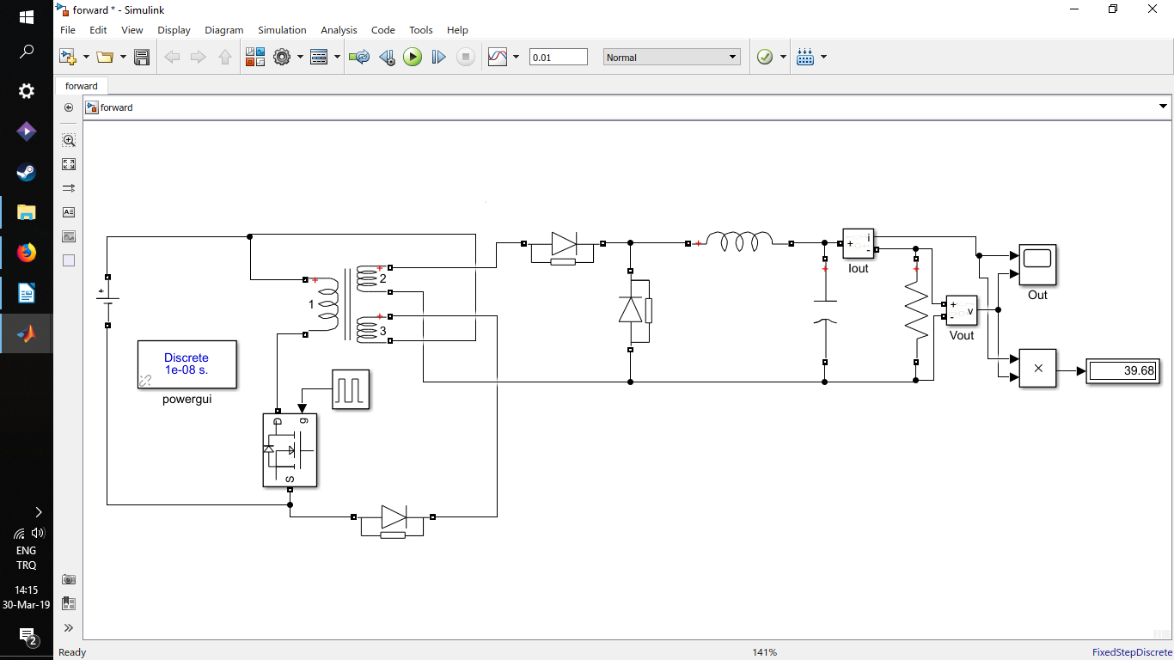

Figure a.1: Practical Forward Converter

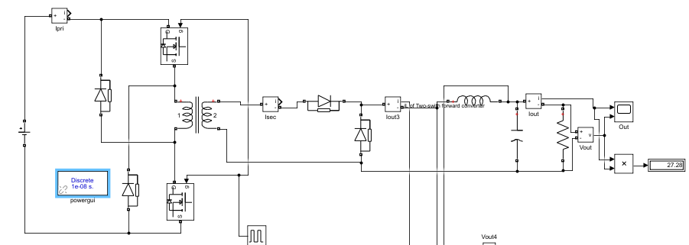

Figure a.2: Two Switch Forward Converter

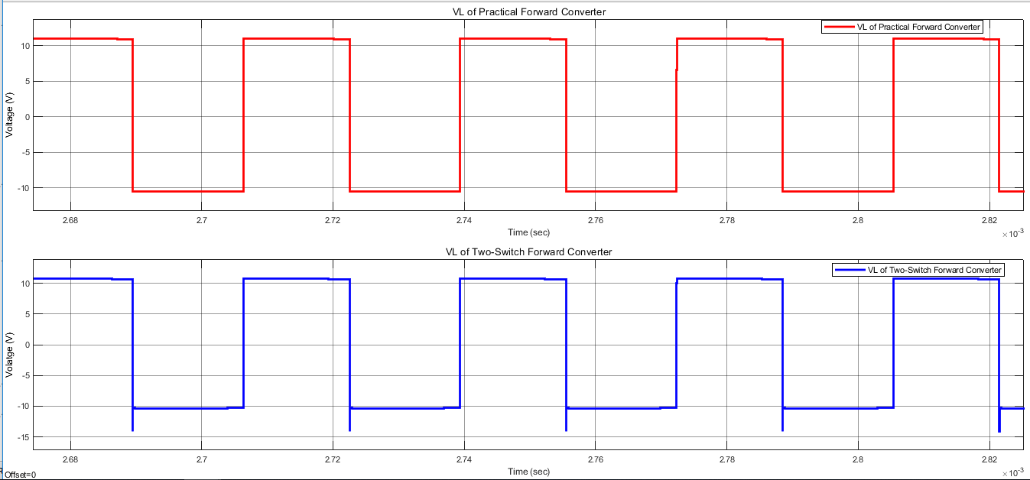

Figure a.3: VL waveforms of the converters

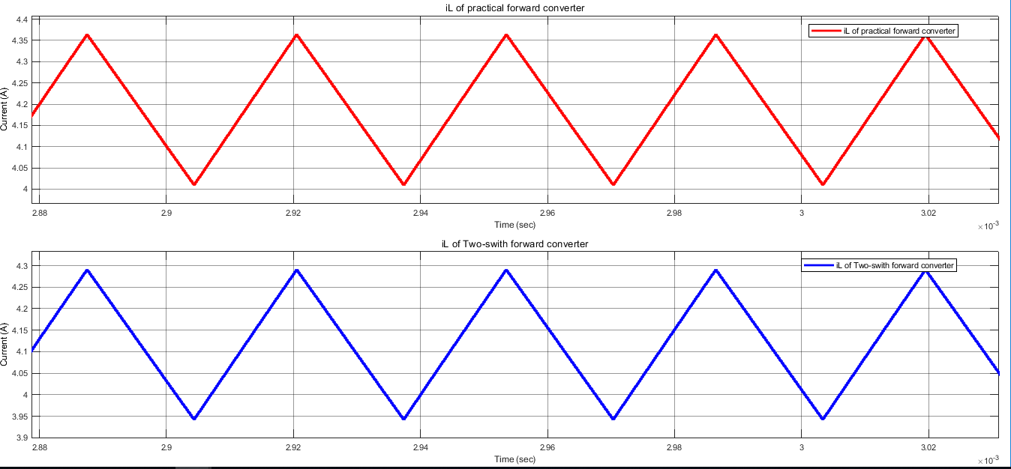

Figure a.4: iL waveforms of the converters

The waveforms of the current passing through the inductor are identical to each other. However, according to voltage waveforms voltage overshoots occur on the inductor in the Two-Switch Converter when the switches are off. As we remember from the last semester, it is easy to burn an inductor coil, so we decided to make calculations for the Practical converter. Since the voltage rating of the switches in the Two-switch converter is one-half of that in a single-switch topology and N1, N2 values will be the same for both topologies if we decide to change our topology back to Two-Switch Forward Converter, we should be fine.

## Part b: Design of the Transformer

## 

The first step of designing transformer is the calculation of “Area Product” for our design. Area product is a constant which is a product of the cross-section area and window area of the core. One can easily choose suitable core for the transformer with the help of area product. The required area product can be calculated as follows:

(1)

where P is output power of 40 W, J is the current density of 500 circ.mil/A, K is a constant of 0.0005 for forward converter, B is flux density of 1300 Gauss and f is frequency of 30 kHz. The result of this calculation is 1.05 cm4. So, we have checked the cores which is offered by the department and found core *0P43434EC* which has an area product of 1.21 cm4 as can be seen in Fig.b.1.So, This core was suitable for our design and we have decided to use it.

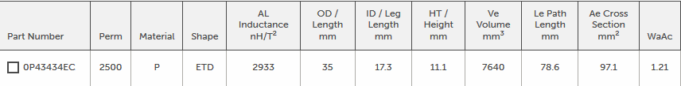

Figure b.1: Selected core’s properties

This core is made from P material and it is an E core with a cylindrical middle leg which can be seen in Fig.b.2.

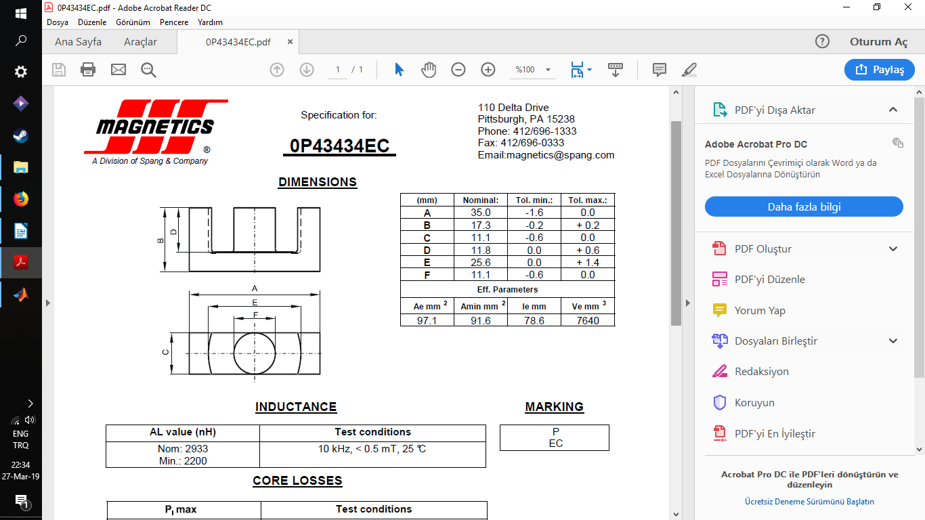

Figure b.2: Selected core’s diagram

Next thing to do was calculating number of turns on primary side of the transformer. For this purpose we have used the following formula.

(2)

where V is maximum voltage of primary side and Ae is the cross section area of the core. We have found required number of turns for primary side as 26. After that, we needed to find secondary number of turns of the transformer. As we all know, input voltage of the transformer changes between 24 to 48 V. Also, it is advised not to increase the duty cycle of the forward converter above 0.5. Because, there should be enough time for reset circuit to send remaining current to secondary side. So, the transformer should be able to transfer required power at minimum voltage and maximum duty cycle. If input voltage increases to a higher value, we can easily decrease duty cycle to transfer same amount of power. To calculate secondary side number of turns we have used following formula

(3)

We have added a margin voltage to output voltage because there might be a voltage drop because of diodes and inductor. Vpmin is 24 V and Dmax is 0.5 for this case. The resultant secondary side number of turns is 24. Finally, the reset winding number of turns is decided to be equal to primary number of turns which is 32.

Then we have decided the cable size for the transformer. 4 A/mm2 is commonly accepted in power electronics designs. So, we chose AWG 17 for primary side, AWG 15 for secondary side and AWG 25 for reset winding. To check the feasibility of windings we have calculated winding factor.

(4)

Winding factor of the transformer was in acceptable limits. So, we have moved on to DC loss calculation. For this purpose, we needed mean length per turn of the cables so that we can calculate total length of the windings. The following formula calculates mean length per turn for the selected core.

(5)

Essentially, we have calculated the circumference of a circle in this formula. E and F are the values which can be seen in Fig.b.2. Since, cable will be wound on middle leg of the core, they will pile up closer to the middle. So, there is a factor of 0.5 which takes that into account.

The total DC resistance of the cables is found as 46 mOhm. From I2*R formula, the copper loss of the transformer is found as 0.73 W.

The next thing to do was calculating core loss of the transformer. For this purpose we have used Steinmetz core loss equation which is given in the website of the Magnetics for P type materials.

(6)

T is the ambient temperature which is assumed to be 50 C and Ve is the volume of the core. The core loss of the transformer was found as 0.71 W.

Transformer design is an iterative process which needs recalculation. So, we have written a MATLAB script to ease the process. The purpose of the recalculations was to get a close core and copper loss results. Because it means we have fully utilized the transformer core.

## Part c: Simulation of the converter with ideal switches and transformer

Main parameters of the converter are as such:

* **Input voltage**: 24-48V
* **Output Voltage**: 10V
* **Rout**: 2.5Ω
* **Switching Frequency**: 30kHz
* **Turns ratios:**

From the calculations in Part b, N2/N1 =29/32 and N1/N3 =1.

* **Magnetizing reactance:**

In the datasheet of *0P43434EC,* parameters that can be found from an open circuit test of the transformer are not included. Therefore; we chose Lm = 0.7645.10-3 which is the default value of Simulink transformer model.

* **Output Capacitor and Inductor:**

We chose L = 5.10-4 H and Cout = 10. 10-6 which yields the cut-off frequency around 2200Hz.

According to these parameters, for 24V input and D=0.46, we observe the output characteristics in Figure c.1. For 48V input and D=0.23, we observe Figure c.2. Output characteristics are consistent with Equation 1.

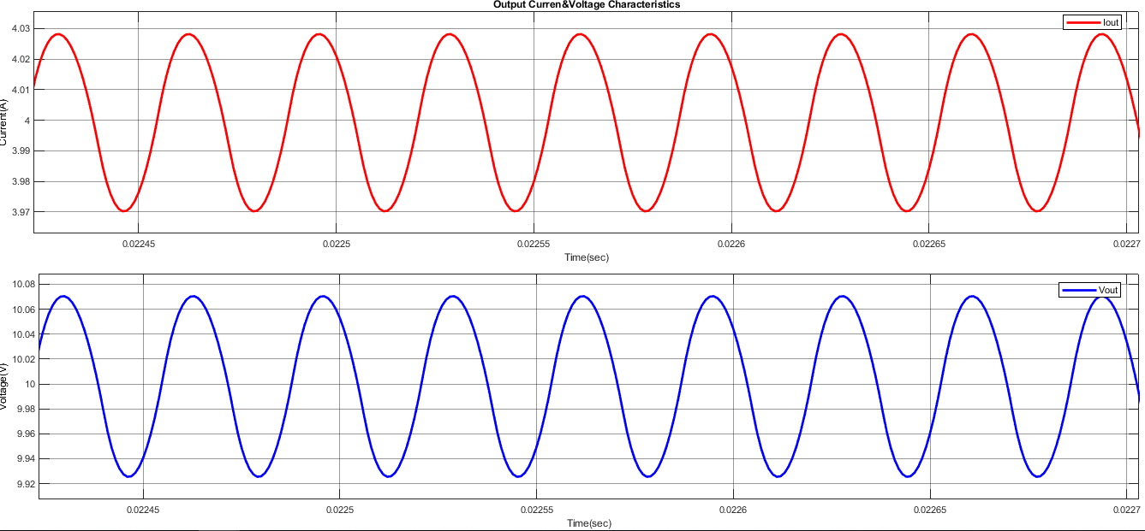

Figure c.1: Output characteristics when 24V input and D=0.46

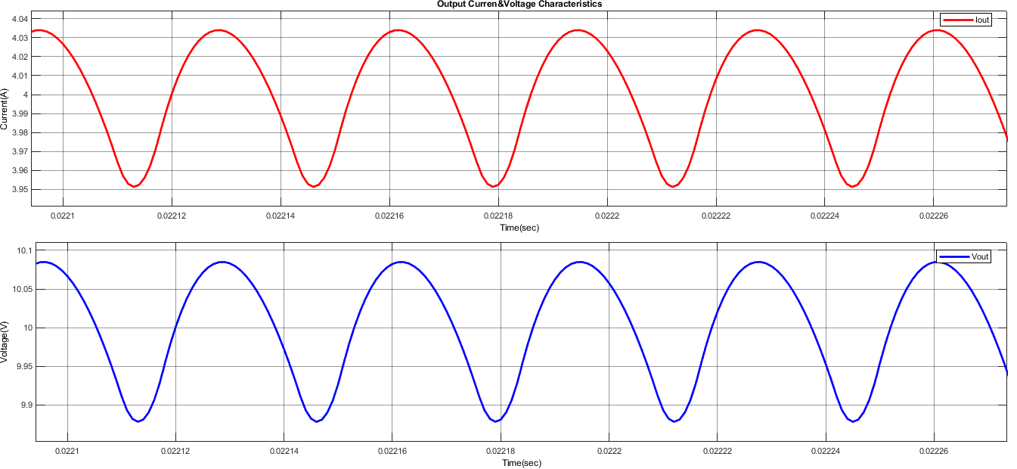

Figure c.2: Output characteristics when 48V input and D=0.23

## Part d: Border of DCM

System parameters for the Forward Converter:

VI = 24V to 48V, VO = 10V, Rout = 2.5 Ω, fs = 30 kHz, L = 5.10-4 H, Lm = 0.7645.10-3

Cout = 10. 10-6 , N2 / N1 = 24/26, N1 / N3 = 1

When VI = 24 V

Hence, if the load current is smaller than **0.18 A**, the converter gets into the DCM.

When VI = 48 V

Hence, if the load current is smaller than **0.25 A**, the converter gets into the DCM.

Now, let’s calculate the magnetizing current ILm with the following formula:

Calculations of min-max transformer current are done for the input voltage value 48V.

## Part e: More Realistic Transformer Simulation

In this part, we have added some parameters to make the simulation more realistic. Forward voltage drop of diodes and the MOSFET, Ron resistance of the MOSFET, inductance of the transformers windings are added to the simulation. Because of the forward voltage drop of the diodes output voltage has decreased to 9.7 V. As a result output power, became 38 W.

Moreover, we have observed a great amount of peak voltage between drain and the source of the MOSFET. You can see the resultant waveforms of drain-source voltage and drain current in following figure.

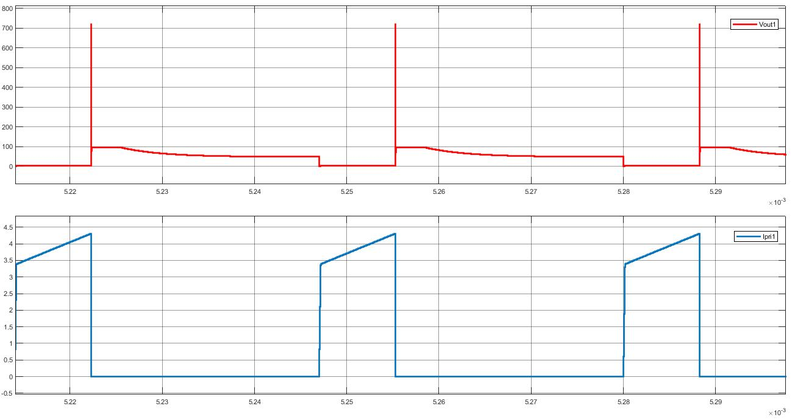

Figure e.1: MOSFET voltage and current waveforms

So, we have decided to use a snubber circuit for MOSFET. Since, we do not want to a lot of power to dissipate at snubber circuit, we have used a 10 nF capacitor and 1 mOhm resistor for snubber. The results can be seen in Fig.e.2. Thanks to this snubber circuitry, we have eliminated the high voltage between drain and the source of the transistor.

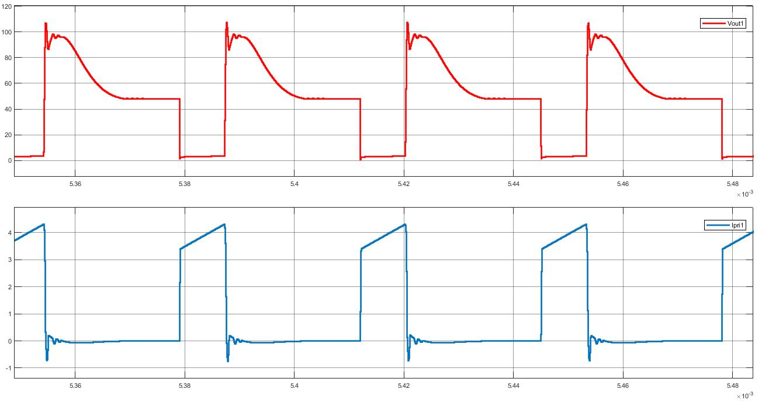Figure e.2: MOSFET voltage and current waveforms with snubber circuit

## 

## Part f: Efficiency of the Converter

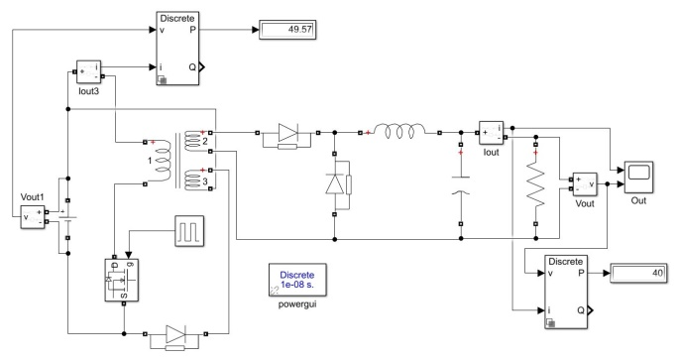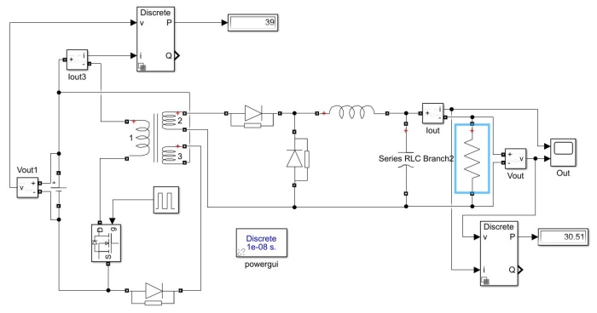

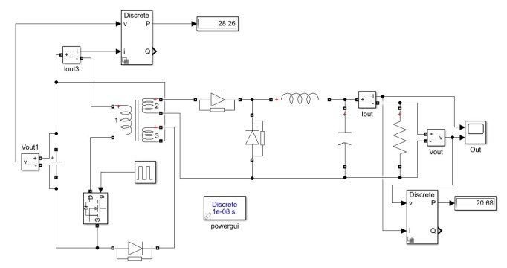 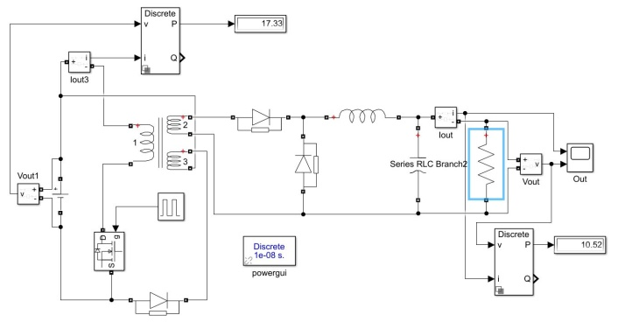

**Figure f.1:** Input and output power displays at different loads respectively (100%, 75%, 50%, 25%)

At full load (R = 2.5 Ω)

At 75% load (R = 3.33 Ω)

At 50% load (R = 5 Ω)

At 25% load (R = 10 Ω)

As can be seen from the Figure f.1 and calculations, at full load highest efficiency is obtained.

## Part g: Converter Operation

First, we have simulated the circuit above with 24 input voltage and %50 duty cycle. The resultant waveform of output current and voltage can be seen in Figure g.1.

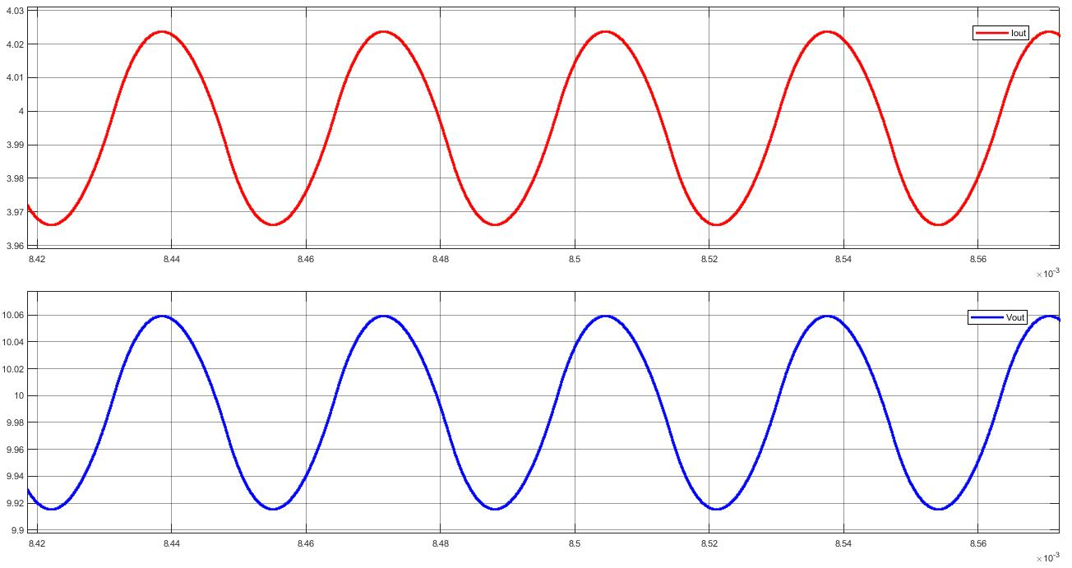

Figure g.1: Output voltage and current waveforms of the practical forward converter

We have achieved 10 V and 4 A output with %1.4 output voltage ripple as can be seen in Figure g.1. When we increased input voltage to 48 V and decreased the duty cycle by half, output power remained the same. The output ripple has increased to %1.8 which can be seen in Figure g.2.

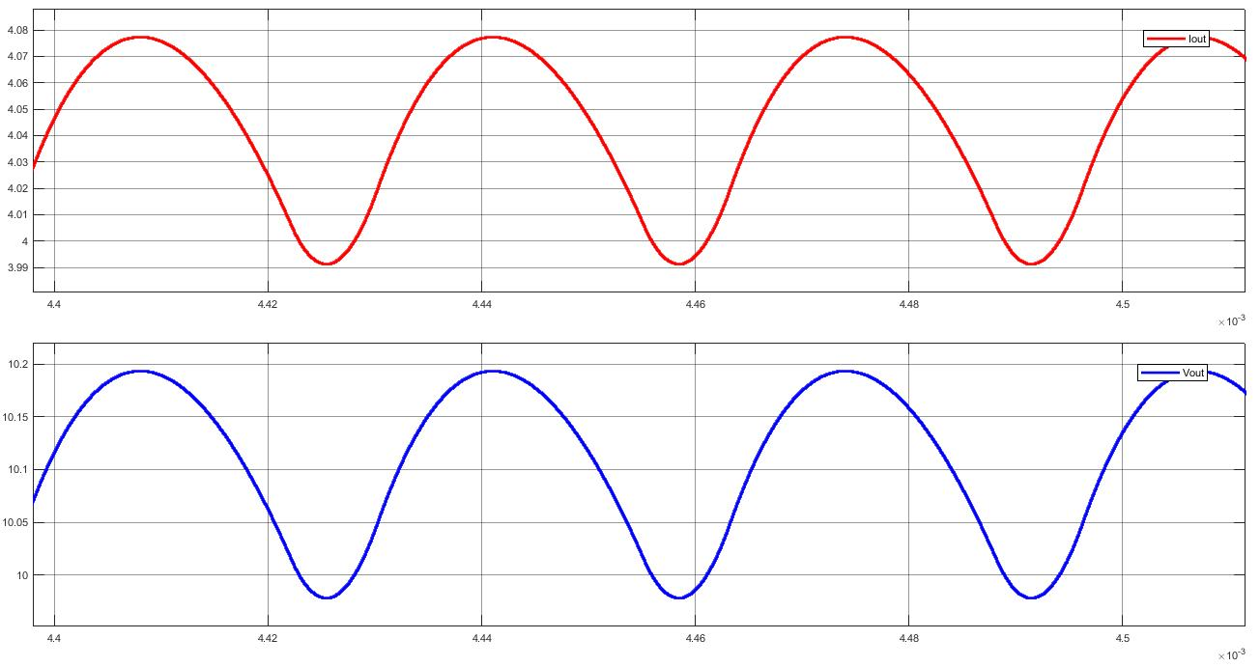

Figure g.2: Output voltage and current waveforms of the practical forward converter with increased input voltage

## Part h: Preliminary Component Selection

In the simulations, we observed that there is an approximately 48V (max.) stress on the secondary side diodes. However, at the primary side diode voltage stress is the double of input voltage as expected (i.e stress is 48V when the input is 24V; stress is 96V when the input is 48V). On the other hand, secondary side current is 4A whereas primary side current is relatively way less than the secondary side. Operating frequency is another concern for our system. Since the frequency is selected as 30 kHz we decided to use schottky diodes with high efficiency and soft recovery.

That’s why we choose two different type diodes for primary and secondary sides.

**Primary Side Diode Selection:** IXYS DSSK 28-006BS (15A, 60V durability)

**Secondary Side Diode Selection**: IXYS DSA30C100PB (15A, 100V durability)

In the simulations, we observed that there is a 700 V switching peak stress on the mosfet, that’s why we decided to use 700V stress durable mosfets. On the other hand, current has 4 A with 25% duty cycle.

That’s why we choose a 700V 7A durable mosfet for 30 kHz operation.

**Mosfet Selection:** IXFH6N120

In the simulations, we observed that voltage ripples are less than 2% when the DC link capacitor is 0.1 uF. Voltage stress on the capacitor is 10V.

That’s why we choose a 0.1 uF electrolytic capacitor with 50 V stress durability.

**Output Capacitor Selection:** EKMG500ELLR10ME11D

# CONCLUSION

In this project, we had conducted simulations on our hardware project, Forward Converter #4. The project’s aim is to conduct magnetic calculations of the converter and to decide its main parameters, and finally to select its components.

In part a, we simulated two different topologies which are Two-Switch Forward Converter and Practical Forward Converter. We decided to calculate the parameters of Practical Converter, since we believe that switching the Two-Switch Converter from it if we change our minds would be easy. In Part b, we designed a three-winding transformer for the converter. Then, in Part c we selected an LC filter and simulated the converter with ideal switches. In Part d, the border of DCM is found. In Part e, we moved on a more realistic converter model and observed the stress on the switches. Hence, we designed a snubber circuit for them. In Part g, we showed that the converter works within the given input voltage limits and satisfies the output ripple limits. Finally, in Part h we selected components for our project.